Create a simple cloud software application for product selling using any cloud service provider to demonstrate saas.

Aim
To create a simple cloud-based Product Selling System using Zoho Creator to demonstrate the Software as a Service (SaaS) model.
Procedure
- Login to Zoho Creator and create an application named Product Selling System.
- Create a Product Details form with Product ID, Product Name, Category, Price, and Stock Quantity.
- Create a Customer Details form with Customer Name, Contact Number, Email, and Address.
- Create an Order Form to select the customer, product, quantity, and order date.
- Add a workflow to automatically calculate the total price based on quantity.
- Update the product stock automatically after an order is placed.
- Add an Order Status field such as Pending, Confirmed, Shipped, and Delivered.
- Create reports for products, customers, orders, and available stock.
- Create a dashboard showing total products, orders, sales, and stock availability.
- Test and deploy the application on the cloud, allowing users to access the system through a web browser.

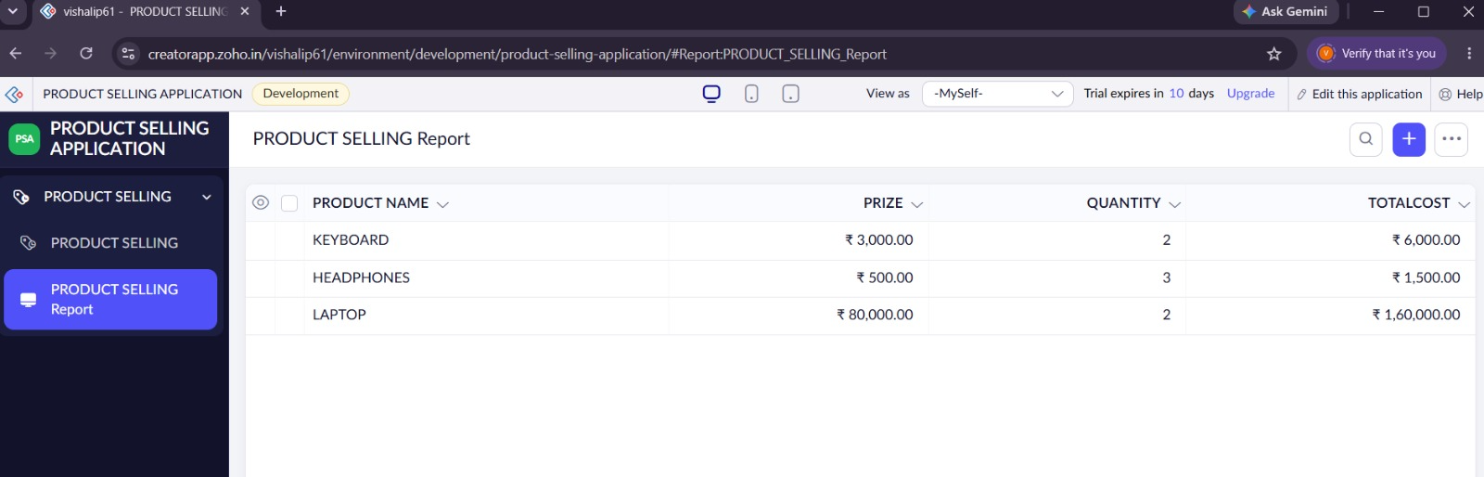
Result
A cloud-based Product Selling System was successfully developed using Zoho Creator, demonstrating the SaaS model.

